**AWS Lab 3**

**Leo Reyes**

**Purpose**

The purpose of this lab was to use a Linux Amazon Machine Image (AMI) and configure it to be a webserver. This machine allowed me to create and use an EC2 amazon instance to be able to configure the web server. The machine allowed me to allocate some space in the server for resources such as security groups (SGs) to be used in the web server.

**Process**

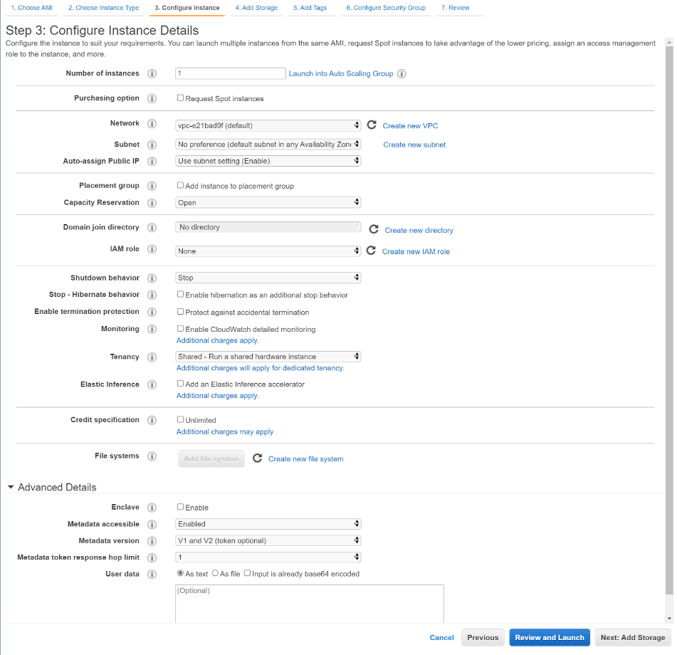

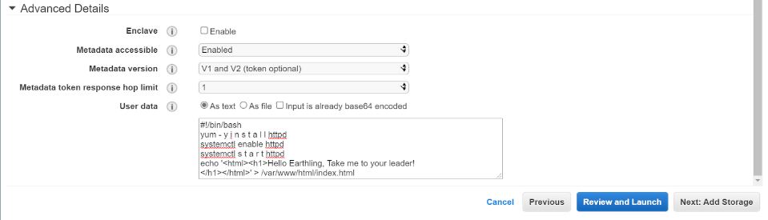

When creating an EC2 Amazon instance, the default settings are kept, but the advanced details are not the same. These details starts the Apache HTTP server as well as creates an index.html page for the web server.

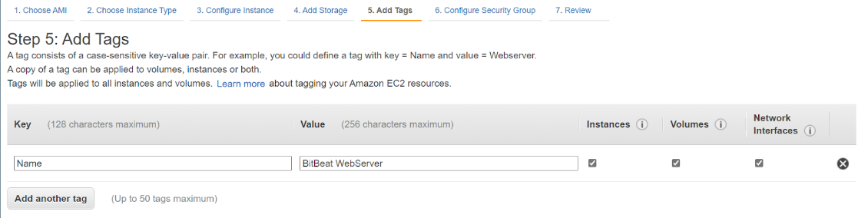

Creating a tag for the web server will allow for the security groups later to be assigned and make it easier for the instance to be found in security groups. These security groups help defend the resources for the web server.

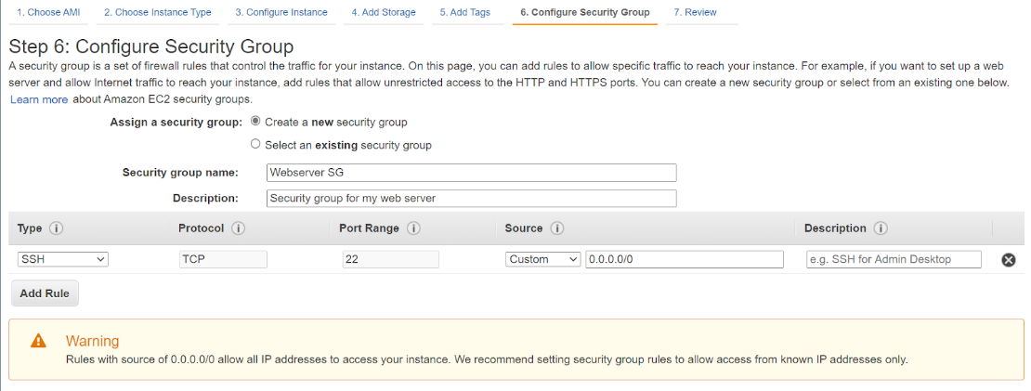

Creating a new security group will allow for new settings to be configured in the instance. This will determine who can access the web server as well as how they can get it. The security group protects the web server and the instance.

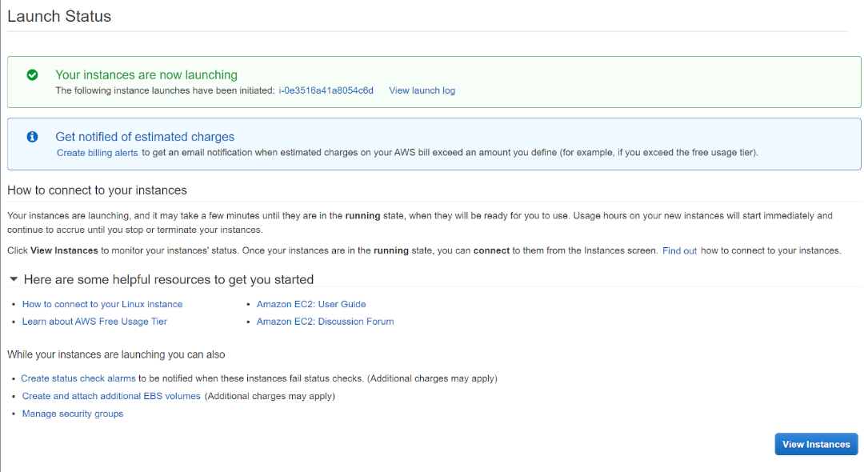

After creating the instance and continuing without a key pair, the instance is up and running.

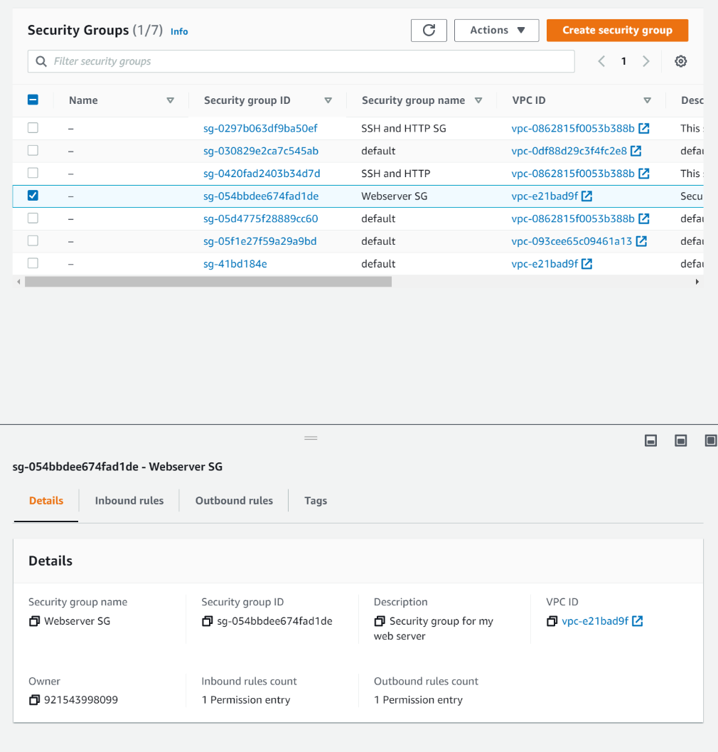

Since the security groups are set up to use 0.0.0.0/0 and 0::0 for both ipv4 and ipv6, and no HTTP rules are set, anyone can access the web server. As seen in the details in the security groups, no HTTP rules are set.

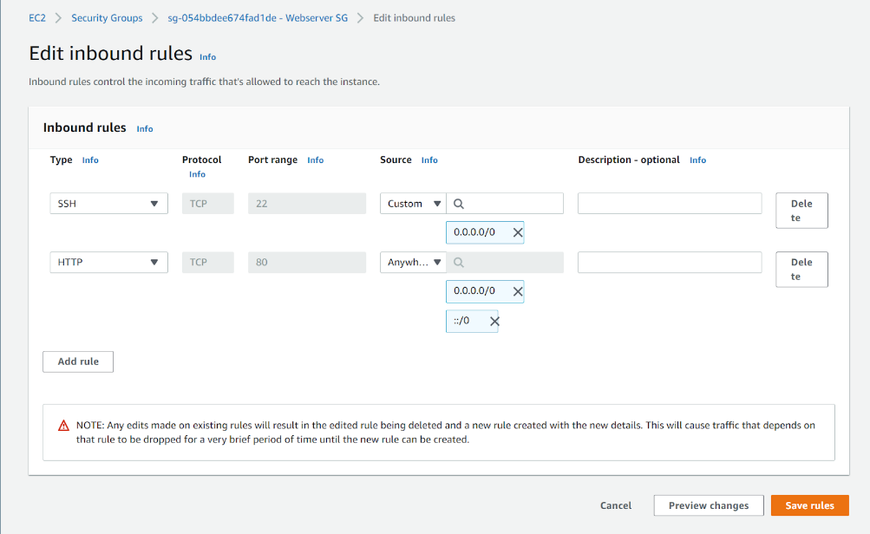

This new rule makes it so that the security group has better security.

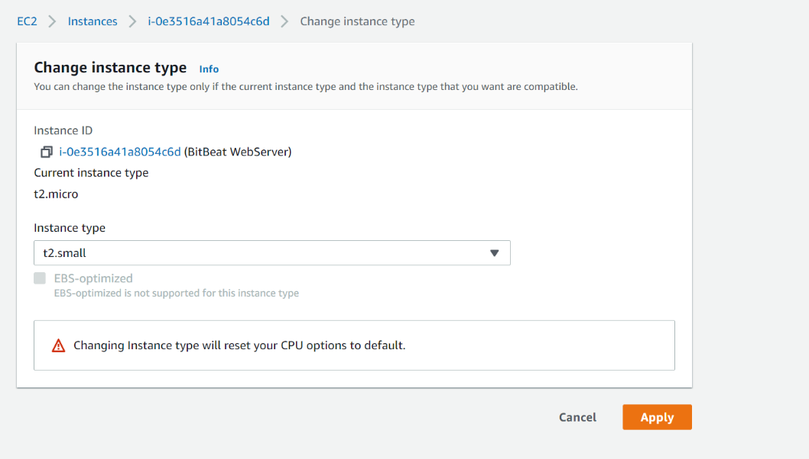

When changing the instance type, it allows for more space in the EC2 instance and it will allow for more resources to be used.

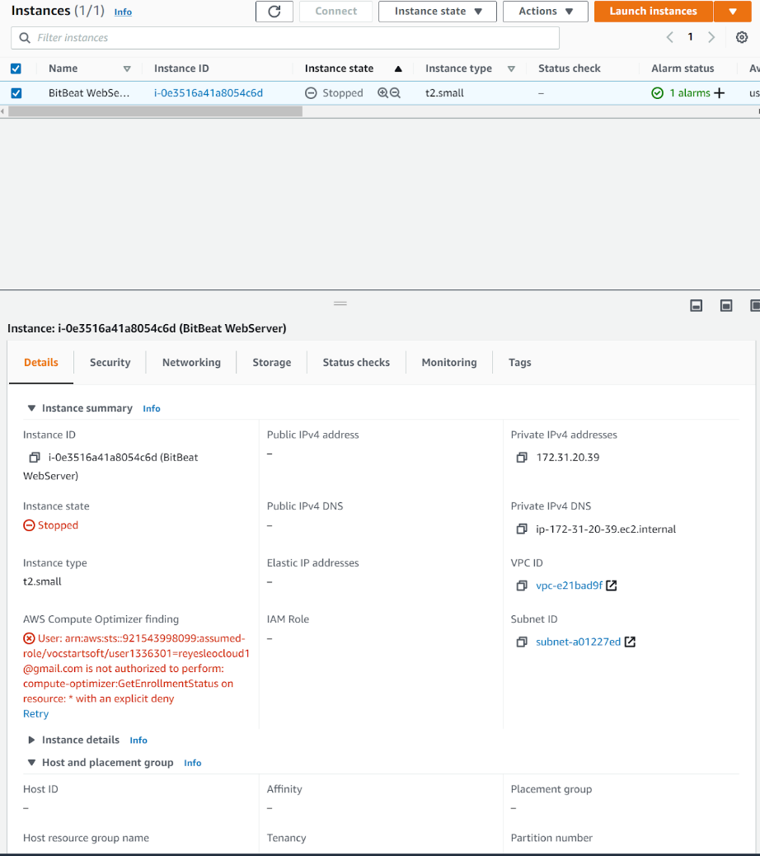

The details of the instance are seen at the bottom of the page from the EC2 console when selecting instances.

**Conclusion**

In conclusion, this lab helped me see how creating EC2 instances can have security issues when leaving it with default settings. After going through this lab, I was able to learn how to give the EC2 Amazon instance more space for more resources to be available to a web server. In addition, I was able to review how to create security groups for the instance and how that can block unauthorized users from accessing the web server.